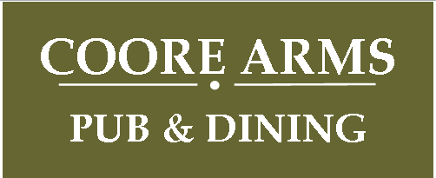

Christmas Party Menu 2019

2 Course £16.95 3 Course £19.95

Starter
Chef’s home-made spiced parsnip and sweet pear soup
Smooth pork and roast pancetta pate
with red onion & orange marmalade
Smoked haddock & crab fishcakes with home made tartare sauce
Gruyere and courgette ciabatta melt O

Main Course
Traditional roast turkey with apricot & chestnut stuffing
Roast topside of beef with Yorkshire pudding
Pan fried salmon fillet with leek & pancetta cream sauce
Candied winter vegetables and mixed nut wellington with a cranberry centre

All main meals served with all the festive trimmings,
herb roast potatoes and a selection of seasonal vegetables

Dessert
Traditional Christmas pudding with brandy sauce
Drunken Baileys and malteser cheesecake and ice cream
Clementine and Drambuie sponge with custard O
Three flavours of local Brymor real dairy ice cream
Speciality cheeseboard – biscuits, fruit & relish ( £2.50 supplement )

Tea or Coffee & a “sweet treat”

